First Flow:
Human in the loop:
This project implements a Human-in-the-Loop (HITL) orchestration system using OpenAI as the core LLM and Lang Graph for workflow coordination.
The system ensures safe, reliable, and reviewable AI outputs by combining automated reasoning with structured human review.
This architecture is ideal for:
- Compliance-sensitive tasks
- Content moderation
- Enterprise workflows
- High-accuracy document generation
- Automated agents with human supervision
Lang Graph flow chart
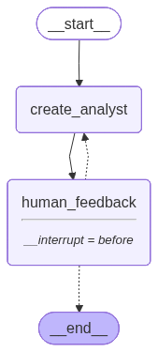
#langchain hashtag#LangGraph hashtag#AIagents hashtag#StructuredOutput hashtag#GenerativeAI hashtag#LangChain hashtag#AIautomation hashtag#llm hashtag#embedding hashtag#ai hashtag#futureai hashtag#generativeai hashtag#genai hashtag#textgeneration hashtag#ragapp hashtag#langchain hashtag#programminglogic hashtag#python hashtag#chatbot hashtag#openai hashtag#gpt hashtag#langchainj hashtag#rag hashtag#crossencoder hashtag#transformers hashtag#multiretriever hashtag#ragfusion hashtag#advancerag hashtag#llamaindex hashtag#langchain hashtag#gemini hashtag#google hashtag#rag hashtag#LCEL hashtag#langgraph hashtag#aiagent hashtag#react hashtag#aiagents
Krish Naik
Sunny Savita
Mayank Aggarwal
-------------------------------------------------------------- Start ---------------------------------------------------------
['You are tasked with creating a set of AI analyst personas. Follow these instructions carefully:\n\n1. First, review the research topic:\neducation\n\n2. Examine any editorial feedback that has been optionally provided to guide creation of the analysts: \n\nplease exaplain only on AI\n\n3. Determine the most interesting themes based upon documents and / or feedback above.\n\n4. Pick the top 4 themes.\n\n5. Assign one analyst to each theme.', 'Generate the set of analysts.']

